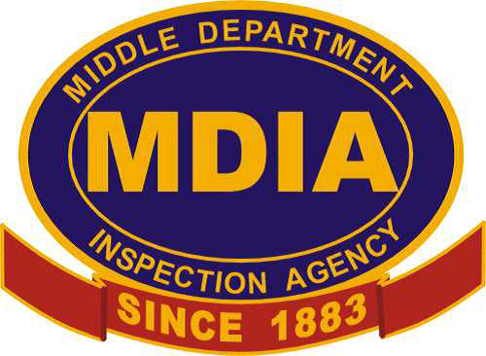
MDIA, INC. and Capital Electric presents “Pools, Piers & Places of Assembly” Seminar

MIDDLE DEPARTMENT INSPECTION AGENCY, INC.

Wednesday, October 9, 2019

From: 7:30 AM to 1 PM at

LaQuinta Inns & Suites

300 S. Salisbury Blvd.

Salisbury, MD 21801

FEATURING:
●Certificate of Completion good for 5 hours of Continuing Education
●MDIA inspectors ●MD & DE approved ●Cecil County approved
●Deluxe continental breakfast provided

Price is $85.00
Pre-registration required by Oct 3rd. Limited space available.
Please bring a 2017 code book if possible.

REGISTRATION FORM-please write name exactly
as it appears on your electrical license.
Name: |  |  |  | Company:
Address:
Phone: |  |  |  | E-mail:
Number of Attendees & Names (Use back if necessary):

❒ | Check | Credit Card No.: |  |  | Expire Date:
❒ | Credit Card | CVD Code | Signature:
Remit payment info to: MDIA, Inc.
8673 Commerce Drive, Unit 2, Easton, MD 21601

